INTRODUCTION

The Online Medicine Ordering System is a web-based application designed to simplify and modernize the process of purchasing medicines. With the rapid growth of digital technology and increasing internet penetration, online platforms have become an essential part of everyday life. The healthcare sector is also evolving to provide more accessible and convenient services, and the Online Medicine Ordering System aims to bridge the gap between customers and pharmacies through an efficient digital solution.

Traditionally, purchasing medicines requires customers to physically visit medical stores, which can be time-consuming, especially during emergencies, adverse weather conditions, or for elderly and physically challenged individuals. Moreover, customers may face difficulties in locating specific medicines, comparing prices, or ensuring availability. The proposed system addresses these challenges by providing an online platform where users can browse medicines, place orders, upload prescriptions (if required), and make secure payments from the comfort of their homes.

The system allows customers to register, log in, search for medicines, add them to a cart, and place orders. It also provides features for viewing order history, tracking order status, and giving feedback. On the administrative side, the system enables administrators to manage medicines, customers, employees, orders, payments, and feedback efficiently. This helps maintain accurate records and ensures smooth business operations
.
Additionally, the system enhances transparency and accuracy by reducing manual errors associated with traditional ordering methods. It improves inventory management, ensures quick order processing, and facilitates better communication between customers and pharmacy staff. The inclusion of online payment options further improves user convenience and supports digital transactions.

The Online Medicine Ordering System is developed using web technologies and database management systems to ensure reliability, scalability, and security. By implementing this system, pharmacies can expand their reach, improve customer satisfaction, and streamline their workflow. Ultimately, the system contributes to providing timely access to medicines and improving overall healthcare service delivery.

Objectives
The main objective of the Online Medicine Ordering System is to develop a user-friendly web-based platform that allows customers to order medicines online easily and efficiently. The system aims to reduce the need for physical visits to medical stores and provide a convenient way for users to purchase medicines from anywhere at any time.
The specific objectives of the system are as follows:
- To provide an online platform for customers to search and order medicines conveniently.
- To allow users to register and maintain their personal profiles securely.
- To enable customers to view medicine details such as name, price, availability, and description.
- To provide a shopping cart feature for adding multiple medicines before placing an order.
- To facilitate secure online payment options for completing transactions.
- To allow customers to view order history and track the status of their orders.
- To provide an admin module for managing medicines, customers, employees, and orders.
- To maintain a centralized database for storing medicine and customer information.
- To reduce manual errors in order processing and inventory management.
- To improve communication between customers and the pharmacy through feedback and notifications.
- To ensure data security and user authentication within the system.
- To provide fast and reliable service for emergency medicine requirements.
The system ultimately aims to enhance customer satisfaction by offering quick access to medicines, improving operational efficiency for pharmacy management, and promoting digital healthcare services.

Existing System:
In the existing system, customers purchase medicines by visiting medical stores physically. This traditional approach involves manual interaction between customers and pharmacists. Customers must travel to the pharmacy, search for required medicines, and wait for availability confirmation. This process is time-consuming and inconvenient, especially for elderly individuals, patients, and people living in remote areas.

The existing system also lacks proper digital record management. Orders are often handled manually, which increases the chances of errors in billing, stock management, and order processing. Customers cannot easily compare prices or check the availability of medicines in advance. Additionally, maintaining manual records makes it difficult for pharmacists to track sales, manage inventory, and analyze customer requirements.

Another limitation of the existing system is the absence of online payment options. Customers must rely on cash transactions, which may not always be convenient. There is also no proper mechanism for tracking previous orders, providing feedback, or receiving notifications regarding medicine availability. These limitations reduce efficiency and customer satisfaction.

Proposed System:
The proposed system introduces an Online Medicine Ordering System that allows customers to order medicines through a web-based platform. This system eliminates the need for customers to physically visit the pharmacy. Users can register, log in, search for medicines, view details, and place orders from anywhere at any time.

The proposed system provides a structured database to manage medicines, customers, employees, orders, payments, and feedback. Administrators can add, update, and delete medicine details, monitor inventory, and manage customer orders efficiently. This reduces manual errors and improves overall system reliability.

The system also supports online payment options, making transactions secure and convenient. Customers can view order history, track order status, and provide feedback. Notifications can be provided for order confirmation and delivery updates.

By implementing the proposed system, pharmacies can improve operational efficiency, reduce paperwork, enhance customer satisfaction, and provide faster access to medicines. The system ensures better data management, improved accuracy, and a modern digital solution for medicine ordering.

Features:

The Online Medicine Ordering System provides various features to enhance user convenience and improve pharmacy management. The key features of the system are listed below:

1. User Registration and Login- The system allows customers to create an account and securely log in using their credentials.

2. Medicine Search- Users can search for medicines by name, category, or keywords for quick access.

3. Medicine Details View- Customers can view detailed information such as medicine name, price, description, and availability.

4. Add to Cart- Users can add multiple medicines to a shopping cart before placing an order.

5. Online Order Placement- Customers can place orders easily by selecting medicines from the cart.

6. Secure Payment Options- The system supports secure online payment methods for completing transactions.

7. Order Tracking- Users can check the status of their orders after placing them.

8. Order History- Customers can view their previous orders and reorder medicines if required.

9. Admin Dashboard- Administrator can manage medicines, customers, employees, orders, and payments.

10. Medicine Management- Admin can add, update, and delete medicine details.

11. Customer Management- Admin can view and manage registered customer information.

12. Employee Management- Admin can manage employee details and assign responsibilities.

13. Inventory Management- The system keeps track of medicine stock and availability.

14. Feedback System- Customers can provide feedback about services and medicines.

Limitation of the system:
Although the Online Medicine Ordering System provides many advantages, it also has certain limitations that must be considered. These limitations are as follows:

1. Internet Dependency
The system requires a stable internet connection. Users without internet access cannot use the platform.

2. Limited to Available Medicines
Customers can only order medicines that are available in the system database. Out-of-stock medicines cannot be ordered immediately.

3. Prescription Verification Challenges
Some medicines require prescriptions, and verifying uploaded prescriptions online may take time or may not always be accurate.

4. Delivery Delays
The system depends on delivery services, which may cause delays due to traffic, weather conditions, or other logistical issues.

5. Technical Issues
Server downtime, software bugs, or system errors may temporarily interrupt services.

6. Limited User Awareness
Some users, especially elderly individuals, may find it difficult to use online systems due to lack of technical knowledge.

7. Security Risks
Although security measures are implemented, there is always a risk of data breaches or cyber threats.

8. Payment Failures
Online payment transactions may fail due to network or banking issues.

9. Dependence on Database Accuracy
Incorrect or outdated medicine information in the database can lead to wrong orders.

10. No Immediate Availability
Unlike physical stores, customers cannot receive medicines instantly and must wait for delivery.

These limitations can be minimized by implementing better security, improving user interface design, ensuring proper system maintenance, and integrating reliable delivery and payment services.

Modules:

It consists three modules such as;

- Admin module
- Employee module
- Customer module

Admin module:

      - Edit profile.
      - Create and View Employee.
      - View customer details.
      - Edit and View Medicine.
      - View order.
      - View payment.

Employee module:

      - Edit profile.
      - View customer details.
      - Create & View Medicine.
      - View order.
      - View payment.

Customer module:

      - Update profile.
      - View medicine.
      - Give order.
      - Purchase item.
      - Make payment
      - Change password

1.7 Project scope:

The Online Medicine Ordering System is designed to provide a comprehensive solution for ordering medicines through an online platform. The scope of this project includes the development of a web-based application that enables customers, administrators, and employees to interact with the system efficiently.

The system allows customers to register, log in, browse available medicines, search for specific medicines, and view detailed information such as price, description, and availability. Customers can add medicines to a shopping cart, update quantities, and place orders. The system also supports online payment functionality and provides order confirmation along with order tracking.

The administrator has full control over the system and can manage medicines by adding, updating, and deleting records. The admin can also manage customers, view all orders, update order status, and generate reports. Inventory management is included to ensure that medicine availability is updated in real time.

Employees can access assigned orders and update delivery status. The system also provides a feedback module where customers can submit their suggestions or complaints.

The project scope covers the following functionalities:

- Customer registration and login
- Medicine browsing and searching
- Shopping cart management
- Order placement
- Online payment processing
- Order tracking
- Admin dashboard
- Medicine management
- Customer management
- Order management
- Feedback system
- Database management

This system is intended for small to medium-sized pharmacies and medical stores. It aims to reduce manual workload, improve operational efficiency, and provide a convenient platform for customers to order medicines from anywhere at any time.

Feasibility Analysis

Feasibility study is an important phase in the software development process. It enables the developer to have an assessment of the product being developed. It refers to the feasibility study of the product in terms of outcomes of the product, operational use and technical support required for implementing it.

Feasibility study should be performed on the basis of various criteria and parameters. The various feasibility studies are:

  - Economic Feasibility
  - Operational Feasibility
  - Technical Feasibility

  - Economic Feasibility: It refers to the benefits or outcomes we are deriving from the product as compared to the total cost we are spending for developing the product. If the benefits are more or less the same as the older system, then it is not feasible to develop the product.
This product is economically feasible as it is a need of every mobile developer. And also because it is commercially available to him on the net, which he can download by paying the reasonable price.

  - Operational Feasibility: It refers to the feasibility of the product to be operational. Some products may work very well at design and implementation but may fail in the real time environment. It includes the study of additional human resource required and their technical expertise.
This product is operationally feasible as it is designed specifically for the mobile application developers. Even this product is tested by implementing this in some other projects like Mobile Browser,MMS editor and even in Client Provisioning.

2.3 Technical Feasibility: It refers to whether the software that is available in the market fully supports the present application. It studies the pros and cons of using particular software for the development and its feasibility. It also studies the additional training needed to be given to the people to make the application work.

SYSTEM DESIGN

Dataflow Diagrams
Dataflow Diagram is a structure analysis tool that is used for graphical representation of Data processes through any organization. The data flow approach emphasis on the logic underlying the system, by using combination of only 4 symbols. It follows a top down approach. A full description of a system actually consists of set of DFD s, which comprises of various levels. And initial over view model is exploded lower level diagrams that show additional feature of the system. Further each process can be broken down into a more detailed DFD. This occurs repeatedly until sufficient details are described.

DFD symbols

Square

It defines a source (originator) or destination of system data.

Arrow

It indicates data flow-data in motion. It is a pipeline through which information flows.

Circle or Bubble

It represents a process that transforms incoming data flow(s) into outgoing data flow(s).

Open Rectangle

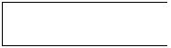

It is a data store-data at rest, or a temporary repository of data.

They are explained by

    - GANE and SARON method
    - DEMACRO YORDAN method

GANE AND SARSON NOTATION

DATA FLOW DATA STRUCTURE

EXTERNAL ENTITY OR DATA LINK

PROCESS

DATA BASE

DEMACRO YORDAN NOTATION

DATA FLOW DATA STRUCTURE

EXTERNAL ENTITY OR DATA LINK

PROCESS

Data-Base 

3.1.1 Data Flow Diagram

Fig-1:

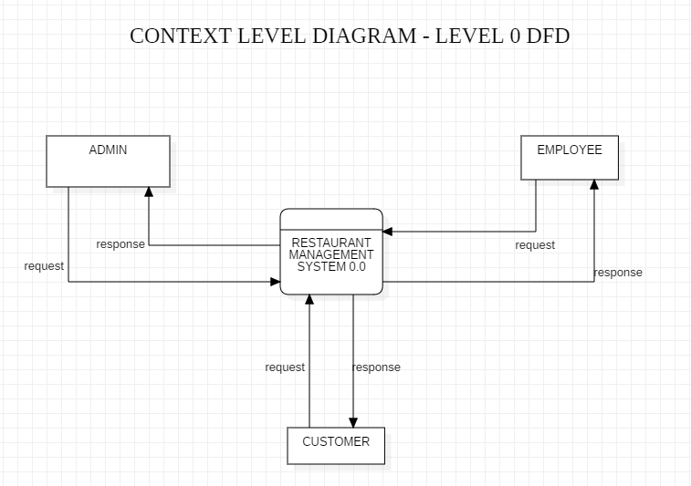

Fig-2:
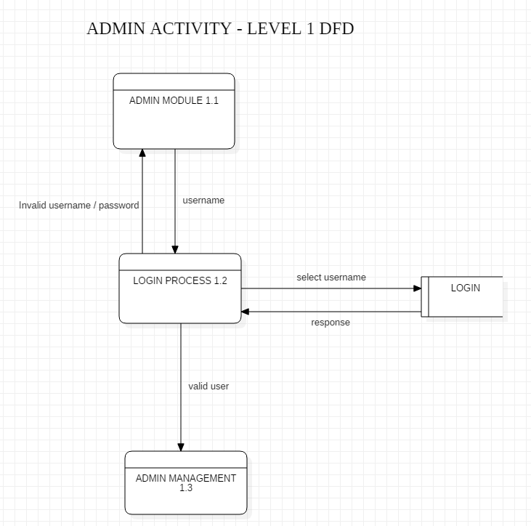

Fig-3:

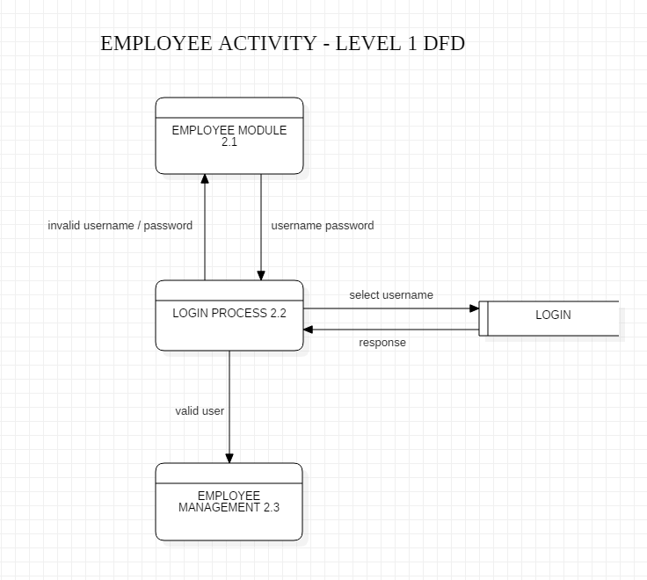

Fig-4:

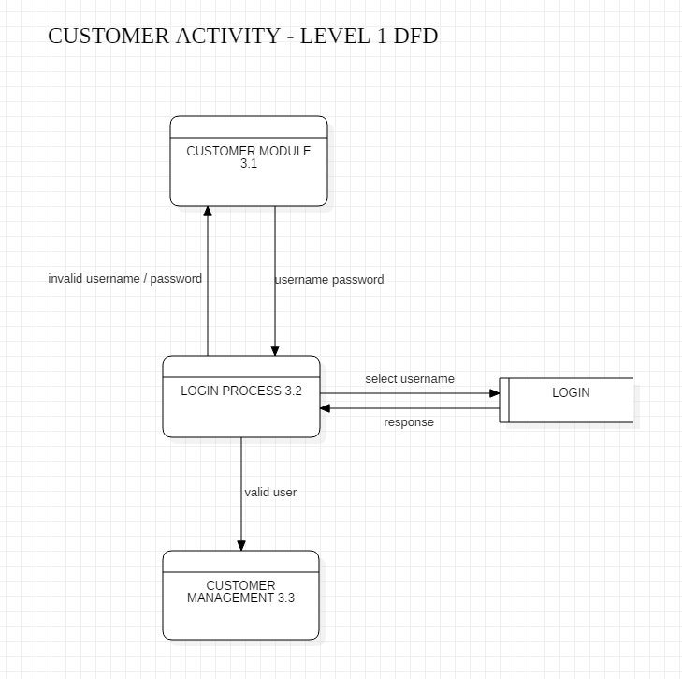

Fig-5:
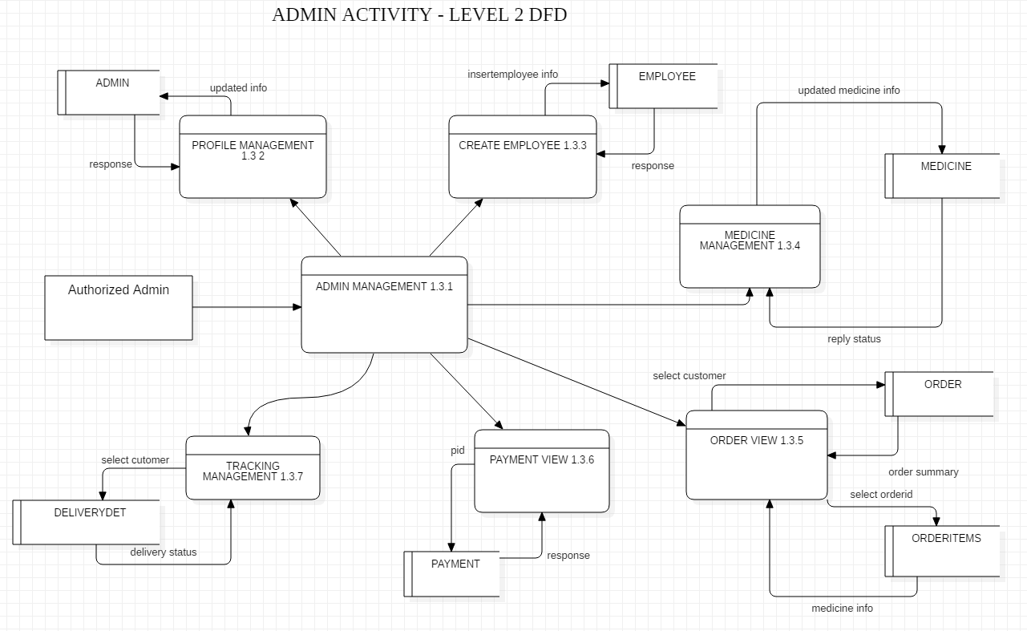

Fig-6:
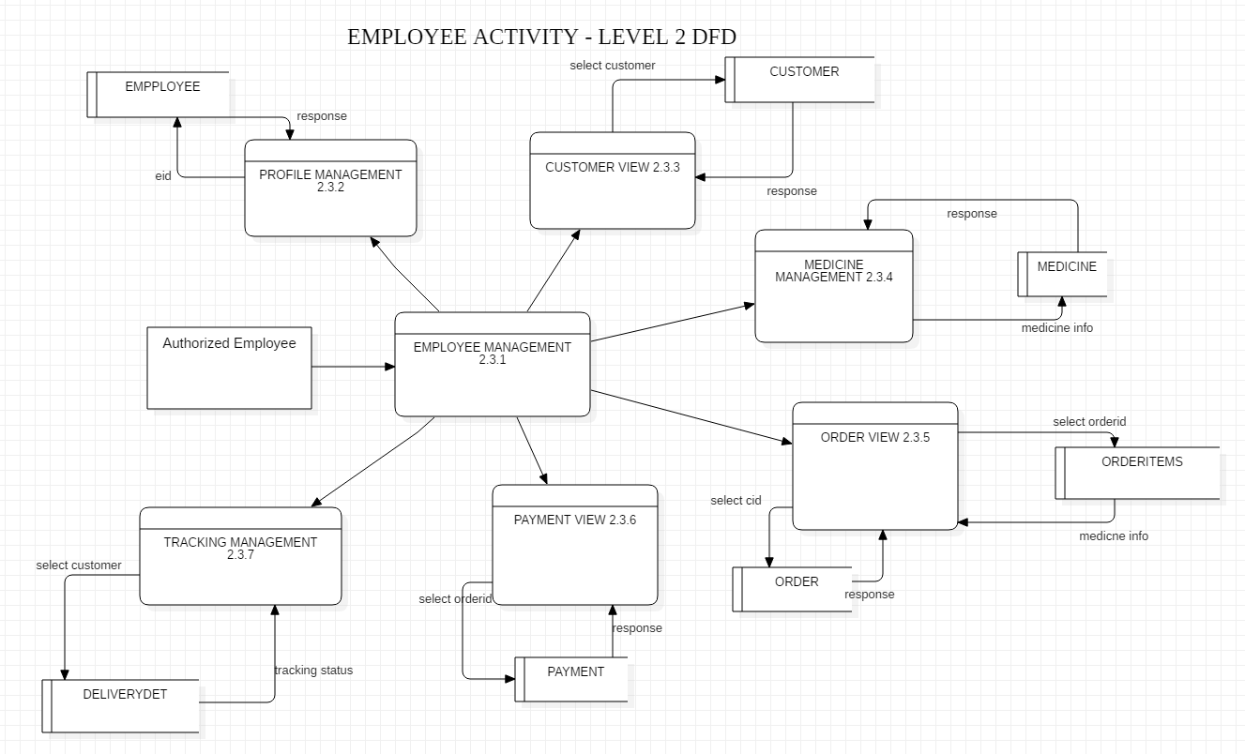

Fig-7
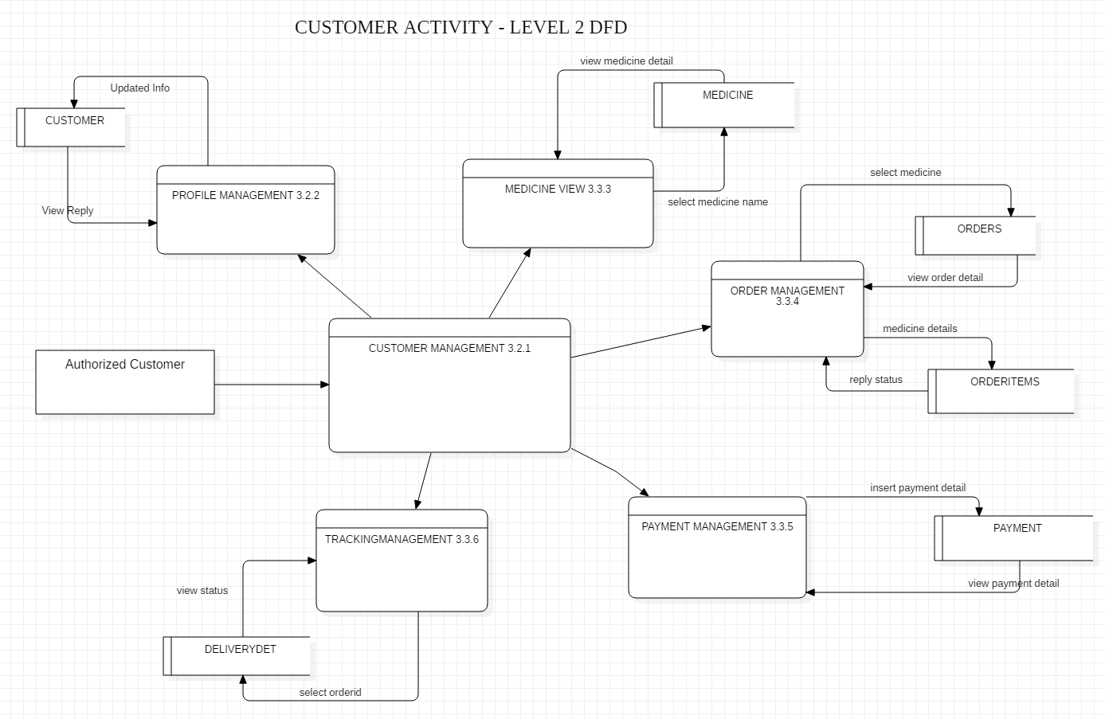

3.2 ER Diagram
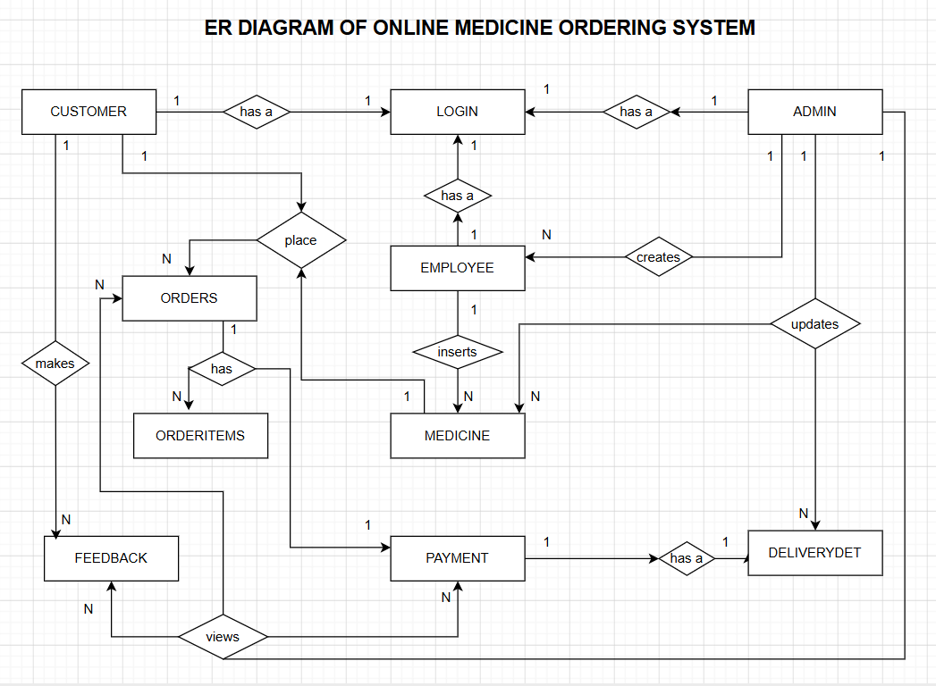

  - UML Diagrams

UML (UNIFIED MODELLING LANGUAGE)

The unified modeling language is a standard language for specifying, Visualizing, Constructing and Documenting the software system and its components. It is a graphical language which provides a vocabulary and set of semantics and rules. The UML focuses on the conceptual and physical representation of the system. It captures the decisions and understandings about systems that must be constructed.
It is used to understand, design, configure, maintain and control information about the systems.

Visualizing:

Through UML we see or visualize an existing system and ultimately we visualize how the system is going to be after implementation. Unless we think we cannot implement. UML helps to visualize how the components of the system communicate and interact with each other.

Specifying:

Specifying means building models that are precise, unambiguous and complete UML addresses the specification of all the important Analysis Design, Implementation decisions that must be made in developing and deploying a software system.

Documenting:

The deliverables of a project apart from coding are some artifacts which are critical in controlling, measuring and communicating about a system during its development.

Diagrams in UML:

Diagrams are graphical presentation of set of elements. Diagrams project a system, or visualize a system from different angles and perspectives.
Static
    - Class diagrams.
    - Object diagrams.
    - Component diagrams.
    - Deployment diagrams

Dynamic:

- Use case diagram.
- Sequence diagram.
- Collaboration diagram.
- State chart diagram.
- Activity diagram.

Static or structural diagrams:

Class diagram:

This shows a set of classes, interfaces, collaborations and their relationships. There are the most common diagrams in modeling the object oriented systems and are used to give the static view of a system.

Object diagram:
Shows a set of objects and their relationships and are used to show the data structures, the static snapshots of instances of the elements in a class diagram. Like class diagram, the object diagrams also address the static design view or process view of a system.

Component diagram:
Shows a set of components and their relationships and are used to illustrate the static implementation view of a system. They are related to class diagrams where in components map to one or more classes, interfaces of collaborations.

Deployment diagram:
Shows a set of nodes and their relationships. They are used to show the static deployment view of the architecture of a system. They are related to the component diagrams where a node encloses one or more components.

Dynamic or behavioral diagrams:

Use Case diagram:
Shows a set of use cases and actors and their relationships. These diagrams illustrate the static use case view of a system and are important in organizing and modeling the behaviors of a system The user who want to learn through online .
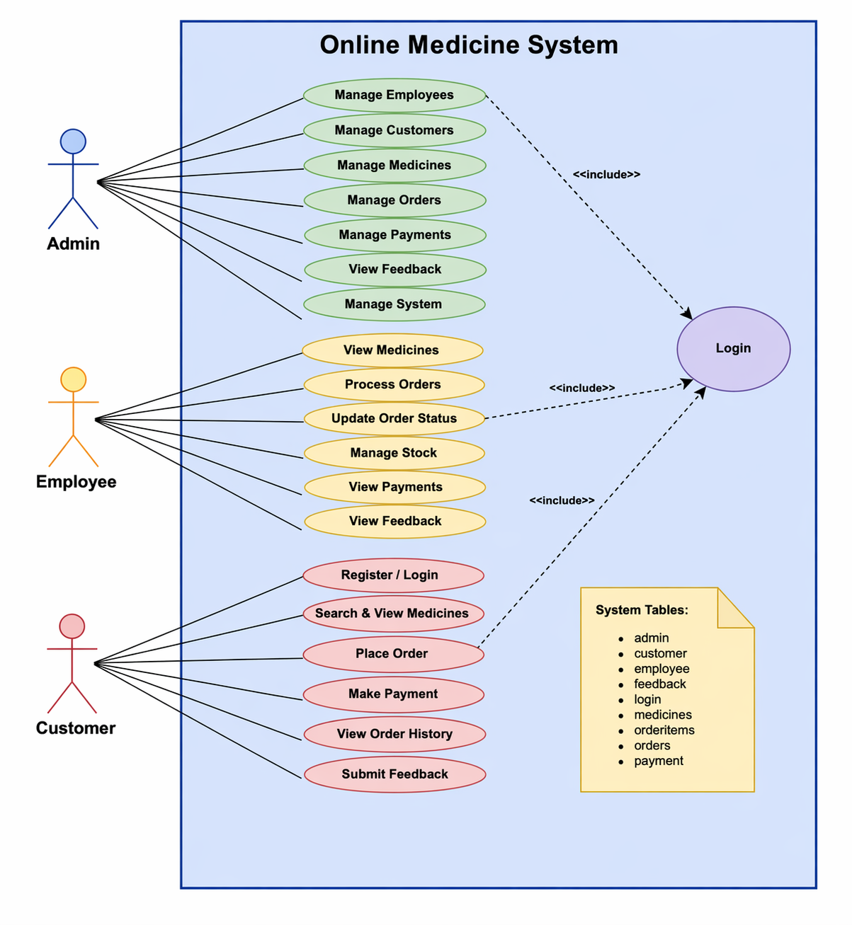

Sequence diagram & collaboration diagram:
These two diagrams are semantically same i.e. the dynamics of a system can be modeled using one diagram and transform it to the other kind of diagram without loss of information.

Sequence diagram:
Sequence diagram is an interaction diagram which focuses on the time ordering of messages it shows a set of objects and messages exchange between these objects. This diagram illustrates the dynamic view of a system.
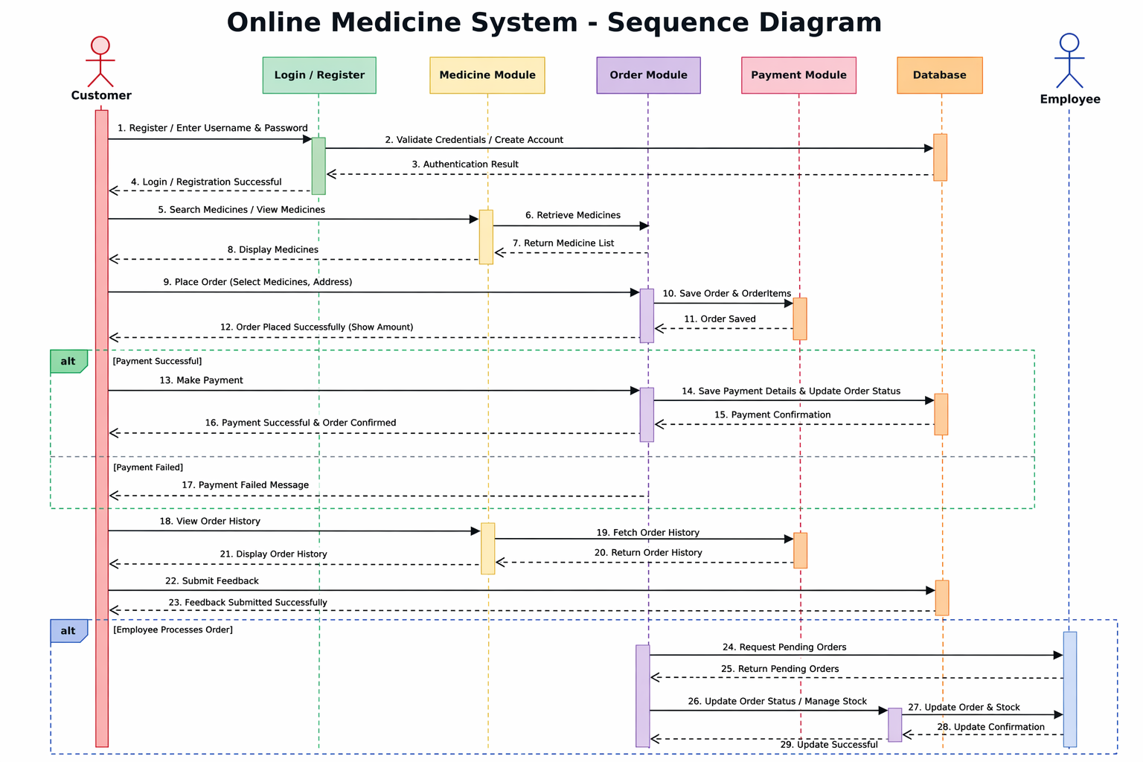

Collaboration diagram:
This diagram is an interaction diagram that stresses or emphasizes the structural organization of the objects that send and receive messages. It shows a set of objects, links between objects and messages send and received by those objects. There are used to illustrate the dynamic vies of a system.

State Chart Diagram and Activity Diagrams:
These Diagrams are semantically similar. State chart diagram shows a state machine consisting of states, transitions and activities these illustrates the dynamic view of a system. They focuses on the event ordered Behavior of an object.

Activity Diagrams:

Activity diagram shows the flow from one activity to another within a system activities may be sequential or branching objects that act and are acted upon. These also show the dynamic view of the system.

Analysis is the detailed study of the various operations performed by a system and their relationships within and outside of the system. A key question is: What must be done to solve the problem? One aspect of analysis is defining the boundaries of the system and determining whether or not candidate system should consider other related systems. During analysis, data are collected on the available files, decision points, and transactions handled by the present system.

- SOFTWARE REQUIREMENT SPECIFICATION

  - WHAT IS SRS?
Software Requirement Specification (SRS) is the starting point of the software developing activity. As system grew more complex it became evident that the goal of the entire system cannot be easily comprehended. Hence the need for the requirement phase arose. The software project is initiated by the client needs. The SRS is the means of translating the ideas of the minds of clients (the input) into a formal document (the output of the requirement phase).

The SRS phase consists of two basic activities:

Problem/Requirement Analysis:
The process is understand the problem, the goal and constraints.

2) Requirement Specification:

Here, the focus is on specifying what has been found giving analysis such as representation, specification languages and tools, and checking the specifications are addressed during this activity.The requirement phase terminates with the production of the validate SRS document. Producing the SRS document is the basic goal of this phase.

ROLE OF SRS:

The purpose of the Software Requirement Specification is to reduce the communication gap between the clients and the developers. Software Requirement Specification is the medium though which the client and user needs are accurately specified. It forms the basis of software development. A good SRS should satisfy all the parties involved in the system.

PURPOSE:

The purpose of this document is to describe all external requirements for System. It also describes the interfaces for the system.

Software Requirements:

Operating System : Windows 7 or higher.
Back End : My Sql 5.1
Validation : JavaScript
Front End : HTML, CSS
Technologies : JDK 1.8,J2EE, JDBC, SERVLETS, JSP
Web Server : Apache Tomcat 9.0
Web Technologies : HTML, JavaScript
Web Browsers : Mozila Firefox,Google Chrome
IDE : Dreamweaver8
Documentation Tool : Microsoft word 2007

Hardware Requirements:
Processor : Intel core -2 duo (min).
RAM : 500MB (min).
Hard Disk : 40 GB (min).

DATABASE DESIGN

Table ADMIN :
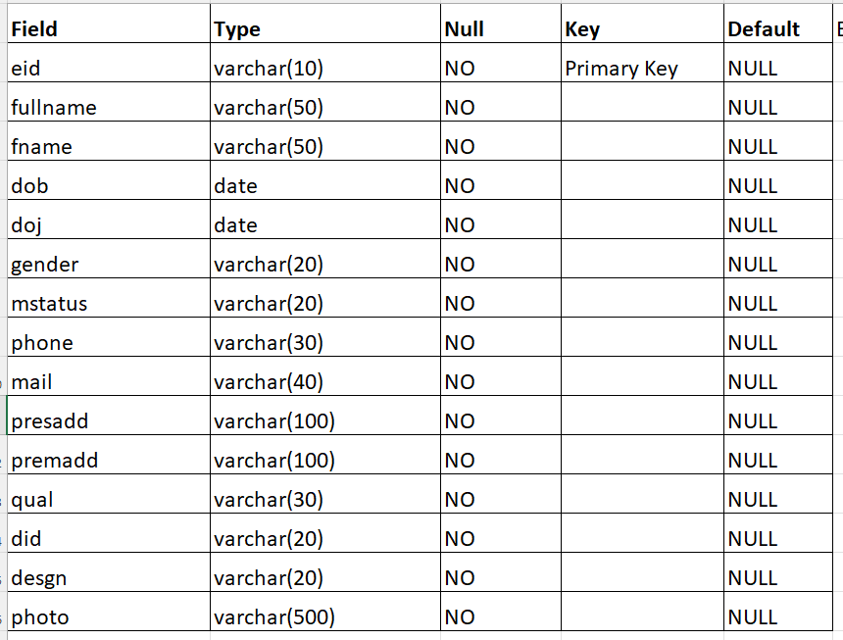

Table EMPLOYEE:
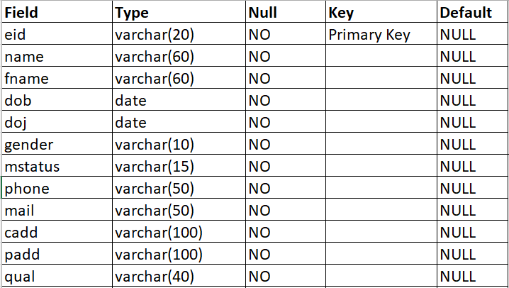

Table MEDICINES:

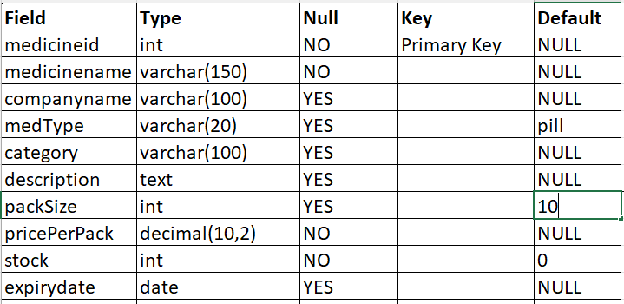
Table FEEDBAK:
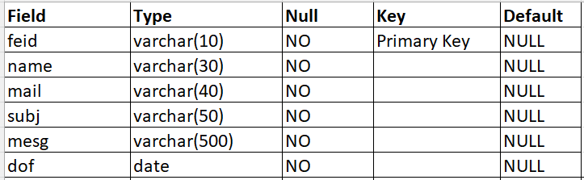

Table LOGIN:
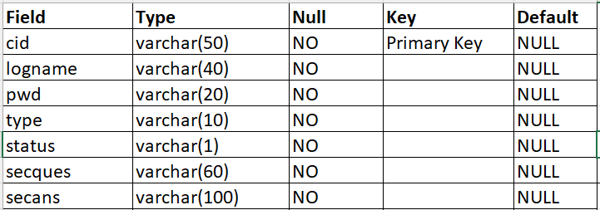

Table CUSTOMER:
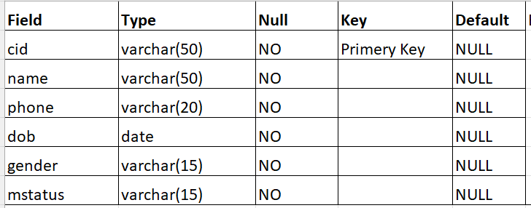
Table ORDERS:
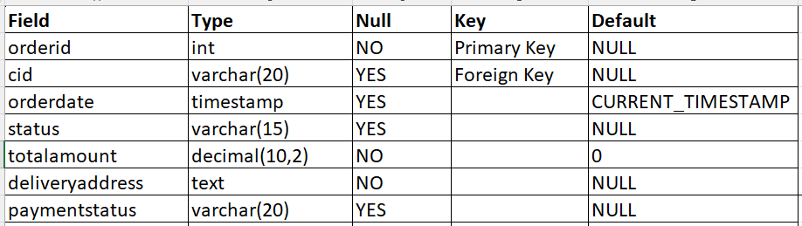

Table ORDERITEMS:
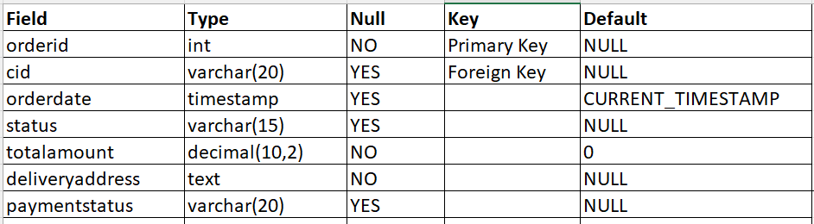

Table PAYMENT:
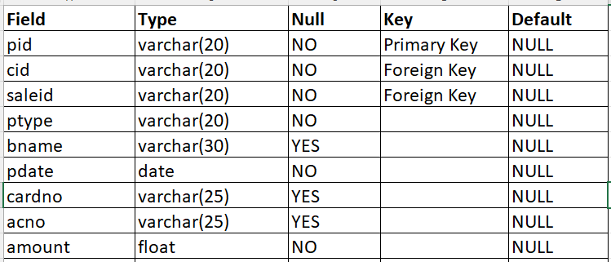

THEORETICAL BACKGROUND

Technologies Used:

HTML
HTML, an initialism of Hypertext Markup Language, is the predominant markup language for web pages. It provides a means to describe the structure of text-based information in a document — by denoting certain text as headings, paragraphs, lists, and so on — and to supplement that text with interactive forms, embedded images, and other objects. HTML is written in the form of labels (known as tags), surrounded by angle brackets. HTML can also describe, to some degree, the appearance and semantics of a document, and can include embedded scripting language code which can affect the behavior of web browsers and other HTML processors.

HTML is also often used to refer to content of the MIME type text/html or even more broadly as a generic term for HTML whether in its XML-descended form (such as XHTML 1.0 and later) or its form descended directly from SGML .
Hypertext Markup Language (HTML), the languages of the World Wide Web (WWW), allows users to produces Web pages that include text, graphics and pointer to other Web pages (Hyperlinks).
HTML is not a programming language but it is an application of ISO Standard 8879, SGML (Standard Generalized Markup Language), but specialized to hypertext and adapted to the Web. The idea behind Hypertext is that instead of reading text in rigid linear structure, we can easily jump from one point to another point. We can navigate through the information based on our interest and preference. A markup language is simply a series of elements, each delimited with special characters that define how text or other items enclosed within the elements should be displayed. Hyperlinks are underlined or emphasized works that load to other documents or some portions of the same document.
HTML can be used to display any type of document on the host computer, which can be geographically at a different location. It is a versatile language and can be used on any platform or desktop.

HTML provides tags (special codes) to make the document look attractive. HTML tags are not case-sensitive. Using graphics, fonts, different sizes, color, etc., can enhance the presentation of the document. Anything that is not a tag is part of the document itself.

Basic HTML Tags:`
<! -- --> specifies comments

<A>………. </A> Creates hypertext links

<B>………. </B> Formats text as bold

<BIG>………. </BIG> Formats text in large font.

<BODY>…</BODY> Contains all tags and text in the HTML document

<CENTER>...</CENTER> Creates text

<DD>…</DD> Definition of a term

<DL>...</DL> Creates definition list

<FONT>…</FONT> Formats text with a particular font

<FORM>...</FORM> Encloses a fill-out form

<FRAME>...</FRAME> Defines a particular frame in a set of frames

<H#>…</H#> Creates headings of different levels (1 – 6)

<HEAD>...</HEAD> Contains tags that specify information about a document

<HR>...</HR> Creates a horizontal rule

<HTML>…</HTML> Contains all other HTML tags

<META>...</META> Provides meta-information about a document

<SCRIPT>…</SCRIPT> Contains client-side or server-side script

<TABLE>…</TABLE> Creates a table

<TD>…</TD> Indicates table data in a table

<TR>…</TR> Designates a table row

<TH>…</TH> Creates a heading in a table

Attributes

The attributes of an element are name-value pairs, separated by "=", and written within the start label of an element, after the element's name. The value should be enclosed in single or double quotes, although values consisting of certain characters can be left unquoted in HTML (but not XHTML).Leaving attribute values unquoted is considered unsafe.
Most elements take any of several common attributes: id, class, style and title. Most also take language-related attributes: lang and dir.
The id attribute provides a document-wide unique identifier for an element. This can be used by stylesheets to provide presentational properties, by browsers to focus attention on the specific element or by scripts to alter the contents or presentation of an element. The class attribute provides a way of classifying similar elements for presentation purposes. For example, an HTML document (or a set of documents) may use the designation class="notation" to indicate that all elements with this class value are all subordinate to the main text of the document (or documents). Such notation classes of elements might be gathered together and presented as footnotes on a page, rather than appearing in the place where they appear in the source HTML.
An author may use the style non-attributal codes presentational properties to a particular element. It is considered better practice to use an element’s son- id page and select the element with a stylesheet, though sometimes this can be too cumbersome for a simple ad hoc application of styled properties. The title is used to attach subtextual explanation to an element. In most browsers this title attribute is displayed as what is often referred to as a tooltip. The generic inline span element can be used to demonstrate these various non- attributes.
The preceding displays as HTML (pointing the cursor at the abbreviation should display the title text in most browsers).

Advantages

- A HTML document is small and hence easy to send over the net. It is small because it does not include formatted information.

- HTML is platform independent.
- HTML tags are not case-sensitive.

JavaScript

JavaScript is a script-based programming language that was developed by Netscape Communication Corporation. JavaScript was originally called Live Script and renamed as JavaScript to indicate its relationship with Java. JavaScript supports the development of both client and server components of Web-based applications. On the client side, it can be used to write programs that are executed by a Web browser within the context of a Web page. On the server side, it can be used to write Web server programs that can process information submitted by a Web browser and then update the browser’s display accordingly
Even though JavaScript supports both client and server Web programming, we prefer JavaScript at Client side programming since most of the browsers supports it. JavaScript is almost as easy to learn as HTML, and JavaScript statements can be included in HTML documents by enclosing the statements between a pair of scripting tags
<SCRIPTS>... </SCRIPT>.

<SCRIPT LANGUAGE = “JavaScript”>

JavaScript statements

</SCRIPT>

Here are a few things we can do with JavaScript:

- Validate the contents of a form and make calculations.
- Add scrolling or changing messages to the Browser’s status line.
- Animate images or rotate images that change when we move the mouse over them.
- Detect the browser in use and display different content for different browsers.
- Detect installed plug-ins and notify the user if a plug-in is required.
We can do much more with JavaScript, including creating entire application.

JavaScript Vs Java

JavaScript and Java are entirely different languages. A few of the most glaring differences are:

- Java applets are generally displayed in a box within the web document; JavaScript can affect any part of the Web document itself.
- While JavaScript is best suited to simple applications and adding interactive features to Web pages; Java can be used for incredibly complex applications.

There are many other differences but the important thing to remember is that JavaScript and Java are separate languages. They are both useful for different things; in fact they can be used together to combine their advantages.

Advantages

  - JavaScript can be used for Sever-side and Client-side scripting.
  - It is more flexible than VBScript.
  - JavaScript is the default scripting languages at Client-side since all the browsers supports it.

Java Technology

Initially the language was called as “oak” but it was renamed as “Java” in 1995. The primary motivation of this language was the need for a platform-independent (i.e., architecture neutral) language that could be used to create software to be embedded in various consumer electronic devices.
- Java is a programmer’s language.
- Java is cohesive and consistent.
- Except for those constraints imposed by the Internet environment, Java gives the programmer, full control.
- Finally, Java is to Internet programming where C was to system programming.

Importance of Java to the Internet
Java has had a profound effect on the Internet. This is because; Java expands the Universe of objects that can move about freely in Cyberspace. In a network, two categories of objects are transmitted between the Server and the Personal computer. They are: Passive information and Dynamic active programs. The Dynamic, Self-executing programs cause serious problems in the areas of Security and probability. But, Java addresses those concerns and by doing so, has opened the door to an exciting new form of program called the Applet.
Java can be used to create two types of programs
Applications and Applets: An application is a program that runs on our Computer under the operating system of that computer. It is more or less like one creating using C or C++. Java’s ability to create Applets makes it important. An Applet is an application designed to be transmitted over the Internet and executed by a Java –compatible web browser. An applet is actually a tiny Java program, dynamically downloaded across the network, just like an image. But the difference is, it is an intelligent program, not just a media file. It can react to the user input and dynamically change.

Features of Java Security

Every time you that you download a “normal” program, you are risking a viral infection. Prior to Java, most users did not download executable programs frequently, and those who did scan them for viruses prior to execution. Most users still worried about the possibility of infecting their systems with a virus. In addition, another type of malicious program exists that must be guarded against. This type of program can gather private information, such as credit card numbers, bank account balances, and passwords. Java answers both these concerns by providing a “firewall” between a network application and your computer.
When you use a Java-compatible Web browser, you can safely download Java applets without fear of virus infection or malicious intent.

Portability

For programs to be dynamically downloaded to all the various types of platforms connected to the Internet, some means of generating portable executable code is needed

- s you will see, the same mechanism that helps ensure security also helps create portability. Indeed, Java’s solution to these two problems is both elegant and efficient.

The Byte code

The key that allows the Java to solve the security and portability problems is that the output of Java compiler is Byte code. Byte code is a highly optimized set of instructions designed to be executed by the Java run-time system, which is called the Java Virtual Machine (JVM). That is, in its standard form, the JVM is an interpreter for byte code.
Translating a Java program into byte code helps makes it much easier to run a program in a wide variety of environments. The reason is, once the run-time package exists for a given system, any Java program can run on it.
Although Java was designed for interpretation, there is technically nothing about Java that prevents on-the-fly compilation of byte code into native code. Sun has just completed its Just in Time (JIT) compiler for byte code. When the JIT compiler is a part of JVM, it compiles byte code into executable code in real time, on a piece-by-piece, demand basis. It is not possible to compile an entire Java program into executable code all at once, because Java performs various run-time checks that can be done only at run time. The JIT compiles code, as it is needed, during execution.

Java Virtual Machine (JVM)

Beyond the language, there is the Java virtual machine. The Java virtual machine is an important element of the Java technology. The virtual machine can be embedded within a web browser or an operating system. Once a piece of Java code is loaded onto a machine, it is verified. As part of the loading process, a class loader is invoked and does byte code verification makes sure that the code that’s has been generated by the compiler will not corrupt the machine that it’s loaded on. Byte code verification takes place at the end of the compilation process to make sure that is all accurate and correct. So byte code verification is integral to the compiling and executing of Java code.

Compilation of code

When you compile the code, the Java compiler creates machine code (called byte code) for a hypothetical machine called Java Virtual Machine (JVM). The JVM is supposed to

execute the byte code. The JVM is created for overcoming the issue of portability. The code is written and compiled for one machine and interpreted on all machines. This machine is called Java Virtual Machine.
Fig-17:

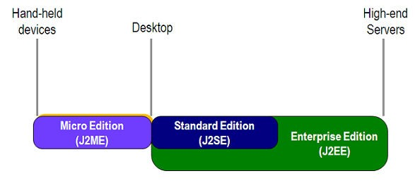

Advantages of java

  - Simple
  - Object Oriented
  - Robust

Java Database Connectivity

What Is JDBC?

JDBC is a Java API for executing SQL statements. (As a point of interest, JDBC is a trademarked name and is not an acronym; nevertheless, JDBC is often thought of as standing for Java Database Connectivity. It consists of a set of classes and interfaces written in the Java programming language. JDBC provides a standard API for tool/database developers and makes it possible to write database applications using a pure Java API.
Using JDBC, it is easy to send SQL statements to virtually any relational database. One can write a single program using the JDBC API, and the program will be able to send SQL statements to the appropriate database. The combinations of Java and JDBC lets a programmer write it once and run it anywhere.
What Does JDBC Do?

Simply put, JDBC makes it possible to do three things:
    - Establish a connection with a database

    - Send SQL statements
    - Process the results.

JDBC versus ODBC and other APIs

At this point, Microsoft's ODBC (Open Database Connectivity) API is that probably the most widely used programming interface for accessing relational databases. It offers the ability to connect to almost all databases on almost all platforms.
So why not just use ODBC from Java? The answer is that you can use ODBC from Java, but this is best done with the help of JDBC in the form of the JDBC-ODBC Bridge, which we will cover shortly. The question now becomes "Why do you need JDBC?" There are several answers to this question:
- ODBC is not appropriate for direct use from Java because it uses a C interface. Calls from Java to native C code have a number of drawbacks in the security, implementation, robustness, and automatic portability of applications.
- A literal translation of the ODBC C API into a Java API would not be desirable. For example, Java has no pointers, and ODBC makes copious use of them, including the notoriously error-prone generic pointer "void *". You can think of JDBC as ODBC translated into an object-oriented interface that is natural for Java programmers.
- ODBC is hard to learn. It mixes simple and advanced features together, and it has complex options even for simple queries. JDBC, on the other hand, was designed to keep simple things simple while allowing more advanced capabilities where required.
- A Java API like JDBC is needed in order to enable a "pure Java" solution. When ODBC is used, the ODBC driver manager and drivers must be manually installed on every client machine. When the JDBC driver is written completely in Java, however, JDBC code is automatically installable, portable, and secure on all Java platforms from network computers to mainframes.
Two-tier and three-tier Models

The JDBC API supports both two-tier and three-tier models for database access.

In the two-tier model, a Java applet or application talks directly to the database. This requires a JDBC driver that can communicate with the particular database management system being accessed. A user's SQL statements are delivered to the database, and the results of those statements are sent back to the user. The database may be located on another machine to which the user is connected via a network. This is referred to as a client/server configuration, with the user's machine as the client, and the machine housing the database as the server. The network can be an Intranet, which, for example, connects employees within a corporation, or it can be the Internet.
Fig-18:

Fig-19:

!

""#$ % !$ &%

'

In the three-tier model, commands are sent to a "middle tier" of services, which then send SQL statements to the database. The database processes the SQL statements and sends the results back to the middle tier, which then sends them to the user. MIS directors find the three-tier model very attractive because the middle tier makes it possible to maintain control over access and the kinds of updates that can be made to corporate data. Another advantage is that when there is a middle tier, the user can employ an easy-to-use higher- level API which is translated by the middle tier into the appropriate low-level calls. Finally, in many cases the three-tier architecture can provide performance advantages.

Until now the middle tier has typically been written in languages such as C or C++, which offer fast performance. However, with the introduction of optimizing compilers that translate Java byte code into efficient machine-specific code, it is becoming practical to implement the middle tier in Java. This is a big plus, making it possible to take advantage of Java's robustness, multithreading, and security features. JDBC is important to allow database access from a Java middle tier.

JDBC Driver Types

The JDBC drivers that we are aware of at this time fit into one of four categories:

  - JDBC-ODBC bridge plus ODBC driver
  - Native-API partly-Java driver
  - JDBC-Net pure Java driver
  - Native-protocol pure Java driver

Steps for Data Base connection
- Import the package.
- Load the driver.
- Establish the connection.
- Create Statement interface
- Perform the queries.
- Close the connection.

About Servlet
What is a Servlet?
Servlet can be described in many ways, depending on the context.
  - Servlet is a technology i.e. used to create web application.
  - Servlet is an API that provides many interfaces and classes including documentations.
  - Servlet is an interface that must be implemented for creating any servlet.
  - Servlet is a class that extend the capabilities of the servers and respond to the incoming request. It can respond to any type of requests.
  - Servlet is a web component that is deployed on the server to create dynamic web page.
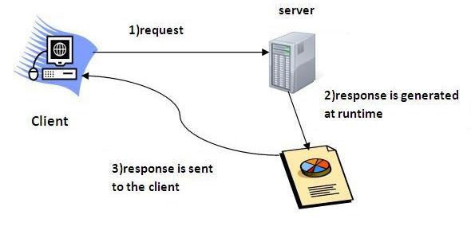
Fig-20

Advantage of Servlet

- better performance: because it creates a thread for each request not process.
- Portability: because it uses java language.
- Robust: Servlets are managed by JVM so no need to worry about momory leak, garbage collection etc.
- Secure: because it uses java language.

Life Cycle of a Servlet
Fig-21

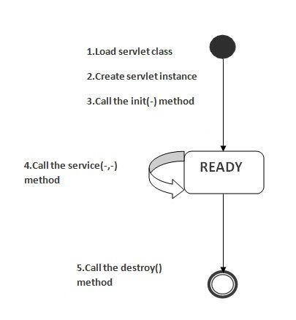

Introduction to JSP
JSP technology is used to create web application just like Servlet technology. It can be thought of as an extension to servlet because it provides more functionality than servlet such as expression language, jstl etc.

Advantage of JSP over Servlet
There are many advantages of JSP over servlet. They are as follows:
- Extension to Servlet
- Easy to maintain
- Fast Development: No need to recompile and redeploy
- Less code than Servlet

Life cycle of a JSP Page
Fig-22

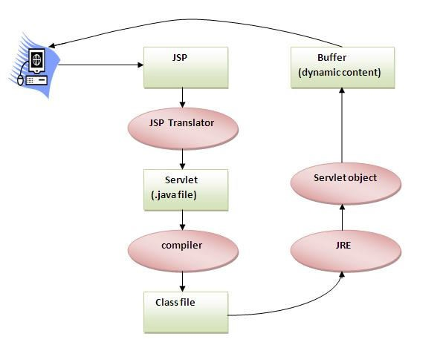
.

Database:
A database management system (DBMS) is computer software designed for the purpose of managing databases, a large set of structured data, and run operations on the data requested by numerous users. Typical examples of DBMSs include Oracle, DB2, Microsoft Access, Microsoft SQL Server, Firebird, PostgreSQL, MySQL, SQLite, FileMaker and Sybase Adaptive Server Enterprise. DBMSs are typically used by Database administrators in the creation of Database systems. Typical examples of DBMS use include accounting, human resources and customer support systems.

Originally found only in large companies with the computer hardware needed to support large data sets, DBMSs have more recently emerged as a fairly standard part of any company back office.

SQL
Structured Query Language (SQL) is the language used to manipulate relational databases. SQL is tied very closely with the relational model.

In the relational model, data is stored in structures called relations or tables. SQL statements are issued for the purpose of:

Data definition: Defining tables and structures in the database (DDL used to create, alter and drop schema objects such as tables and indexes).

Data manipulation: Used to manipulate the data within those schema objects (DML Inserting, Updating, Deleting the data, and Querying the Database). A schema is a collection of database objects that can include: tables, views, indexes and sequencesList of SQL statements that can be issued against an Oracle database schema are:
- ALTER - Change an existing table, view or index definition (DDL)
- AUDIT - Track the changes made to a table (DDL)
- COMMENT - Add a comment to a table or column in a table (DDL)
- COMMIT - Make all recent changes permanent (DML - transactional)
- CREATE - Create new database objects such as tables or views (DDL)
- DELETE - Delete rows from a database table (DML)

- DROP - Drop a database object such as a table, view or index (DDL)
- GRANT - Allow another user to access database objects such as tables or views (DDL)
- INSERT - Insert new data into a database table (DML)
- No AUDIT - Turn off the auditing function (DDL)
- REVOKE - Disallow a user access to database objects such as tables and views (DDL)
- ROLLBACK - Undo any recent changes to the database (DML - Transactional)
- SELECT - Retrieve data from a database table (DML)
- TRUNCATE - Delete all rows from a database table (can not be rolled back) (DML)
- UPDATE - Change the values of some data items in a database table (DML)

- CODING:

TESTING

Testing is a process, which reveals errors in the program. It is the major quality measure employed during software development. During software development. During testing, the program is executed with a set of test cases and the output of the program for the test cases is evaluated to determine if the program is performing as it is expected to perform. In order to make sure that the system does not have errors, the different levels of testing strategies that are applied at differing phases of software development are:

Unit Testing:

Unit Testing is done on individual modules as they are completed and become executable. It is confined only to the designer's requirements.
Each module can be tested using the following two strategies:

Black Box Testing:
In this strategy some test cases are generated as input conditions that fully execute all functional requirements for the program. This testing has been uses to find errors in the following categories:
  - Incorrect or missing functions
  - Interface errors
  - Errors in data structure or external database access
  - Performance errors
  - Initialization and termination errors. In this testing only the output is checked for correctness.
The logical flow of the data is not checked.

White Box testing:

In this the test cases are generated on the logic of each module by drawing flow graphs of that module and logical decisions are tested on all the cases. It has been uses to generate the test cases in the following cases:
  - Guarantee that all independent paths have been executed.
  - Execute all logical decisions on their true and false Sides.

  - Execute all loops at their boundaries and within their operational bounds.
  - Execute internal data structures to ensure their validity.

Integration Testing:

Integration testing ensures that software and subsystems work together a whole. It tests the interface of all the modules to make sure that the modules behave properly when integrated together.

System Testing:

Involves in-house testing of the entire system before delivery to the user. It's aim is to satisfy the user the system meets all requirements of the client's specifications.

Acceptance Testing:

It is a pre-delivery testing in which entire system is tested at client's site on real world data to find errors.

Test Approach:

Testing can be done in two ways:

- Bottom up approach
- Top down approach

Bottom up Approach:
Testing can be performed starting from smallest and lowest level modules and proceeding one at a time. For each module in bottom up testing a short program executes the module and provides the needed data so that the module is asked to perform the way it will when embedded within the larger system. When bottom level modules are tested attention turns to those on the next level that use the lower level ones they are tested individually and then linked with the previously examined lower level modules.

Top down approach:

This type of testing starts from upper level modules. Since the detailed activities usually performed in the lower level routines are not provided stubs are written. A stub is a module shell called by upper level module and that when reached properly will return a

message to the calling module indicating that proper interaction occurred. No attempt is made to verify the correctness of the lower level module.

Validation:

The system has been tested and implemented successfully and thus ensured that all the requirements as listed in the software requirements specification are completely fulfilled. In case of erroneous input corresponding error messages are displayed.

SCREEN SHOTS
Home Page
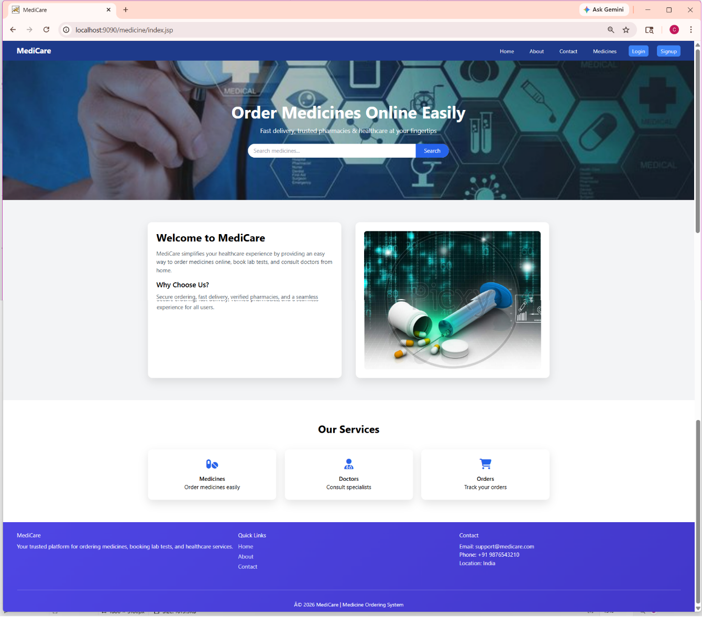

Login Page
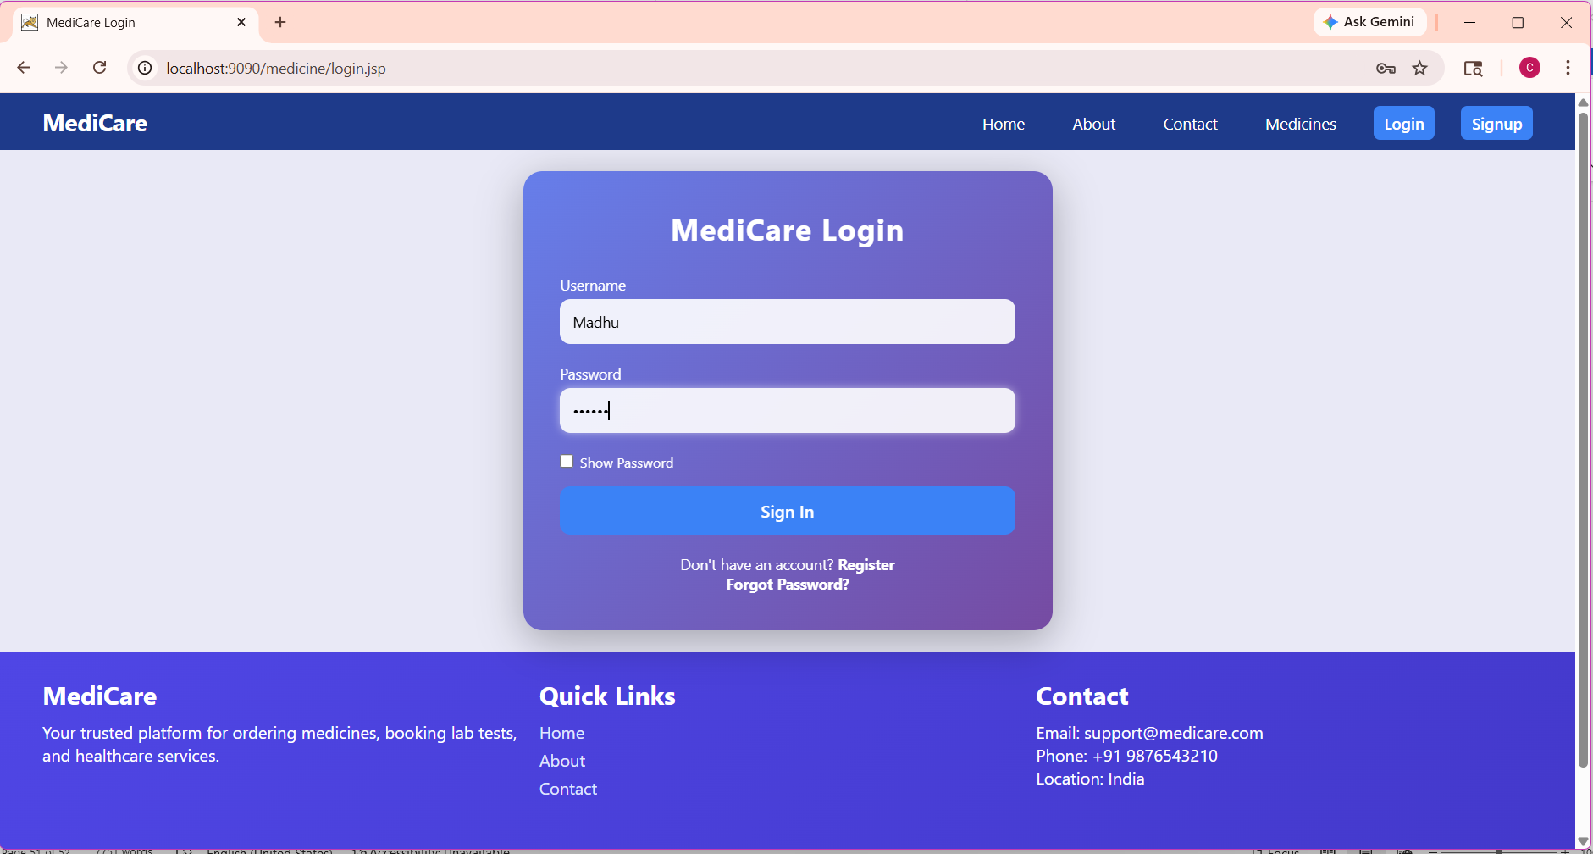

Customer Registration:
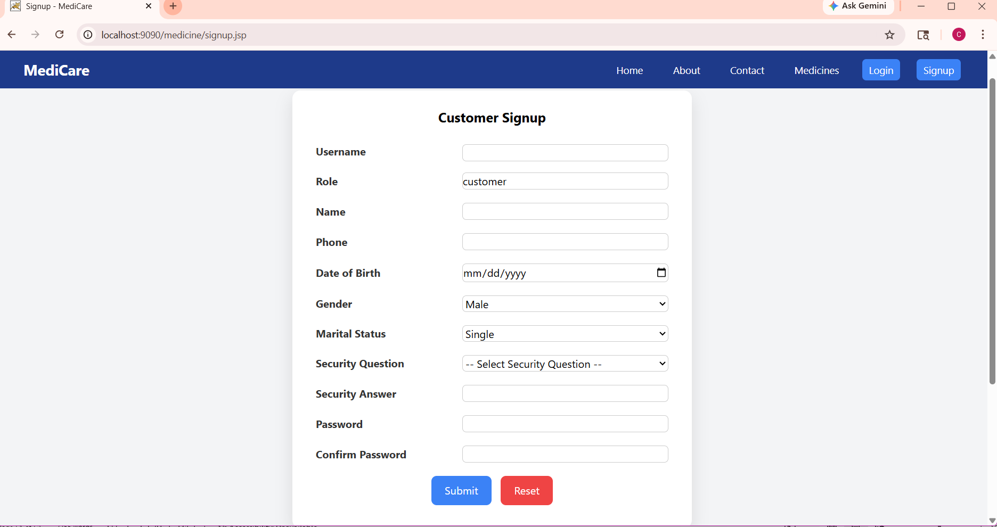

Admin Dashboard
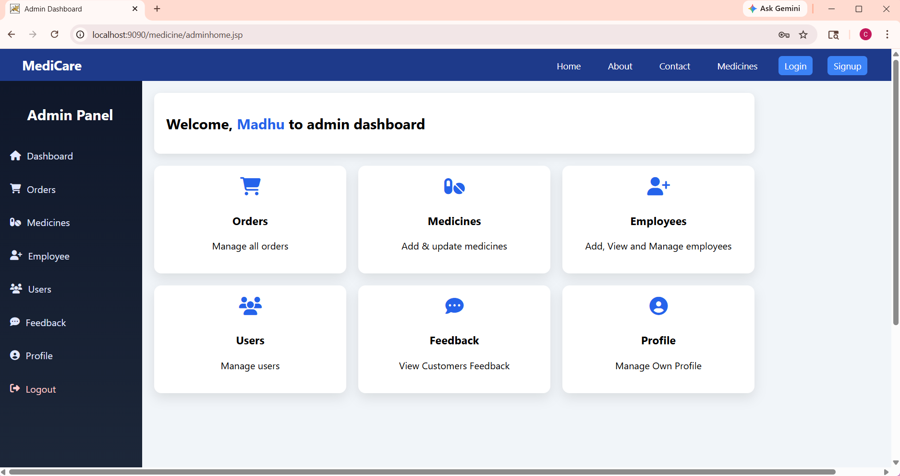

Employee Medicine Entry
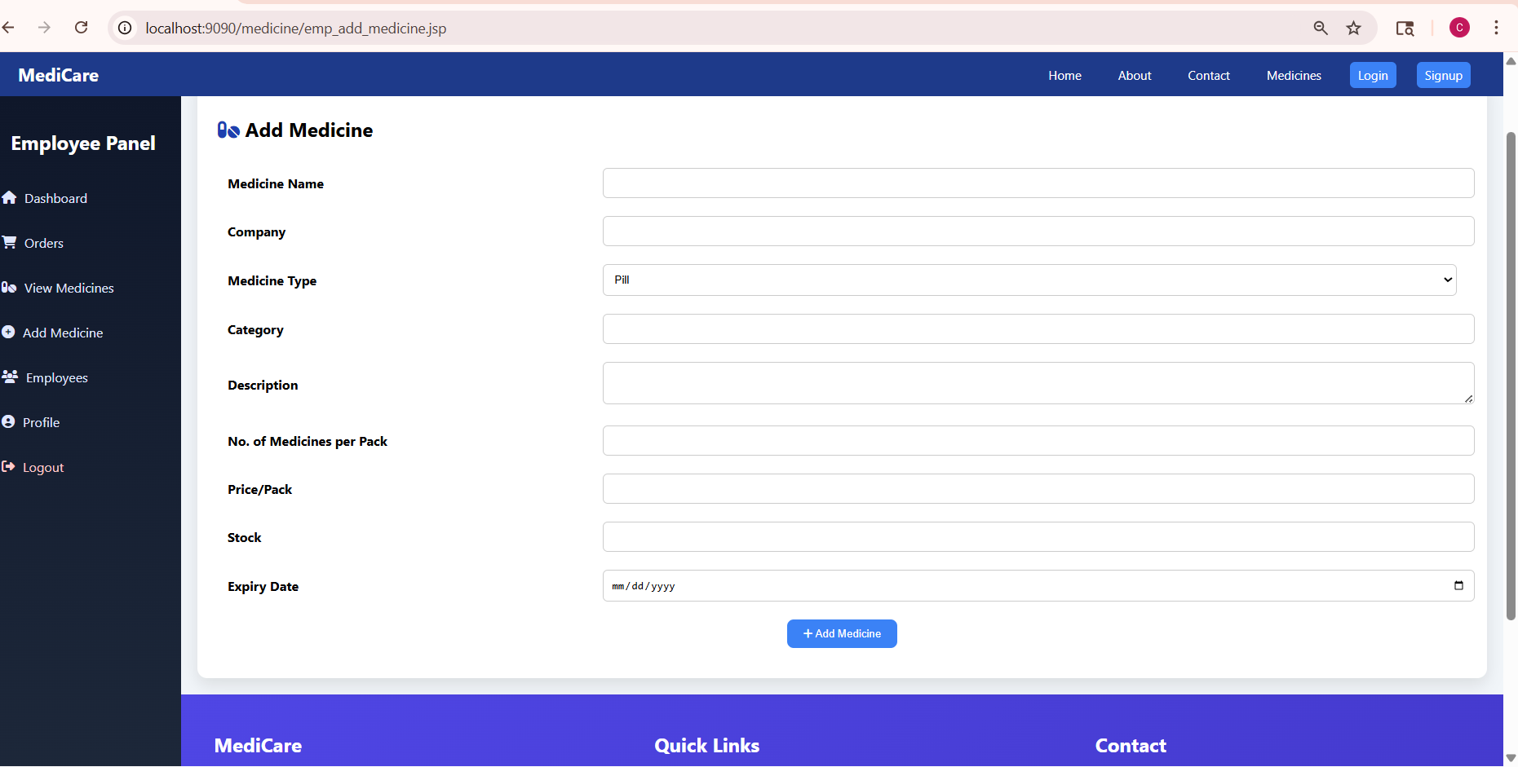

Admin Updates Medicine Info

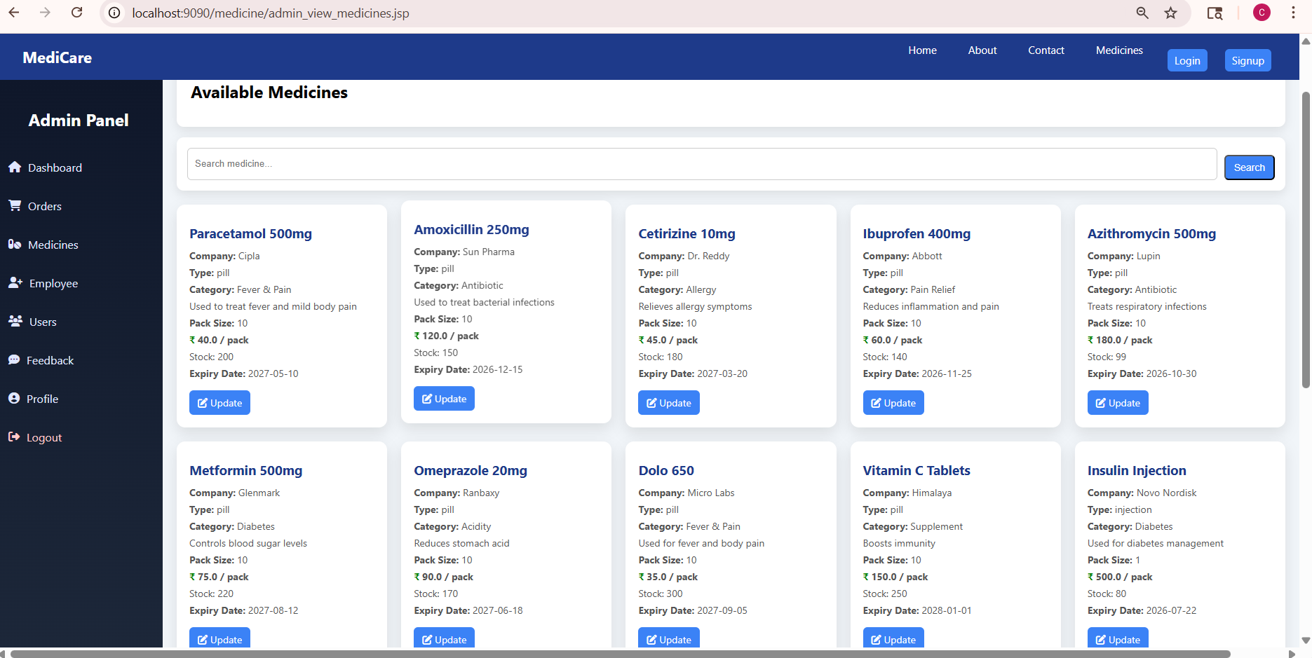

Customer Orders Medicine into Cart:

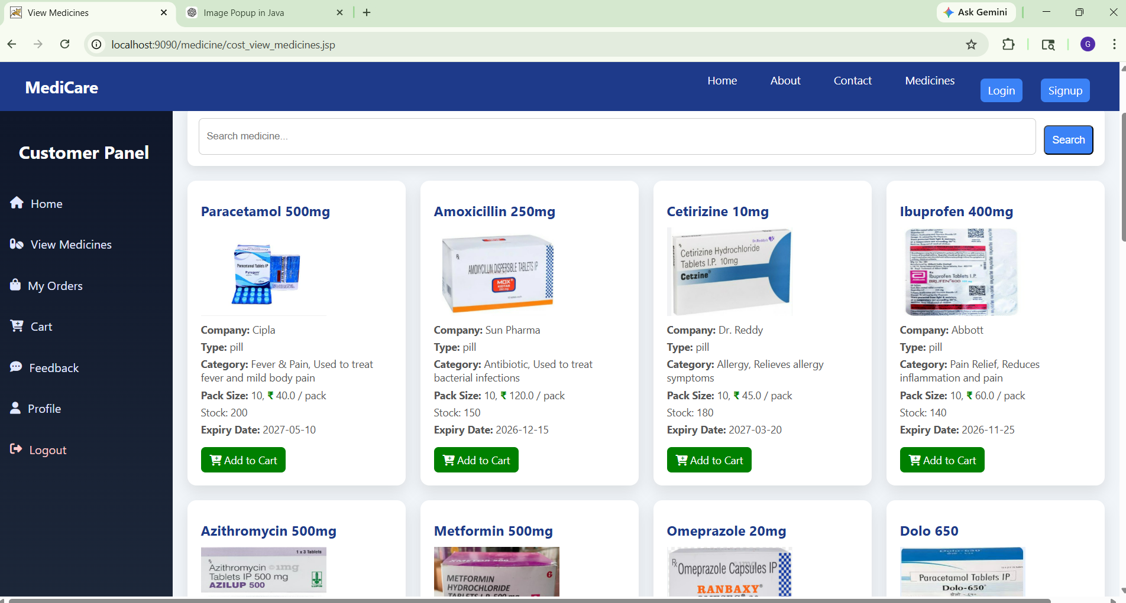

Customer View Cart and Insert Delivery Addresss:

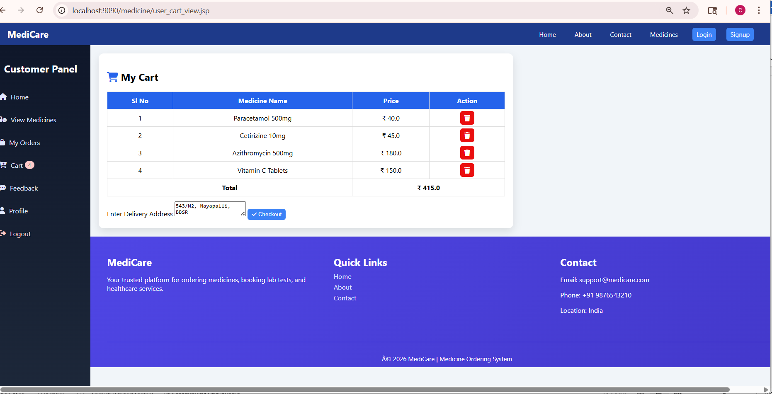

Customer Views Order Summary
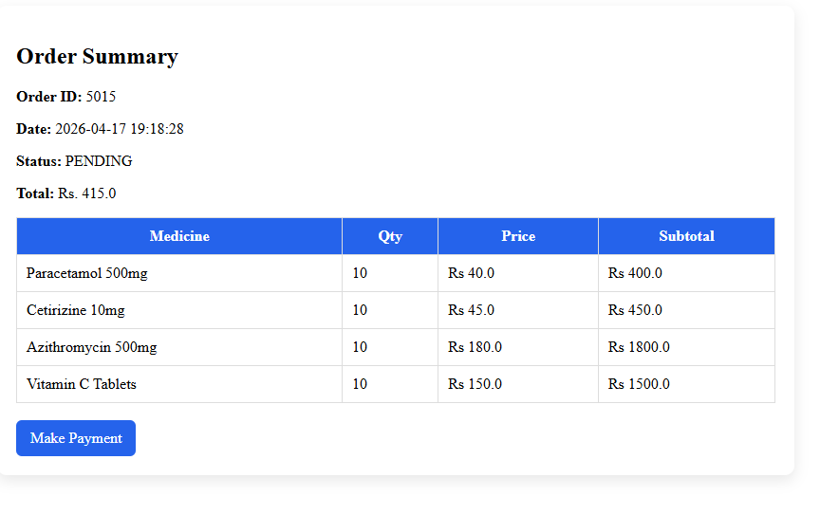

Customer Making Payment

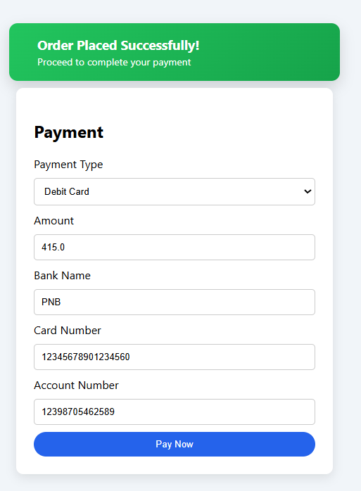

Customer Views Order Summary:
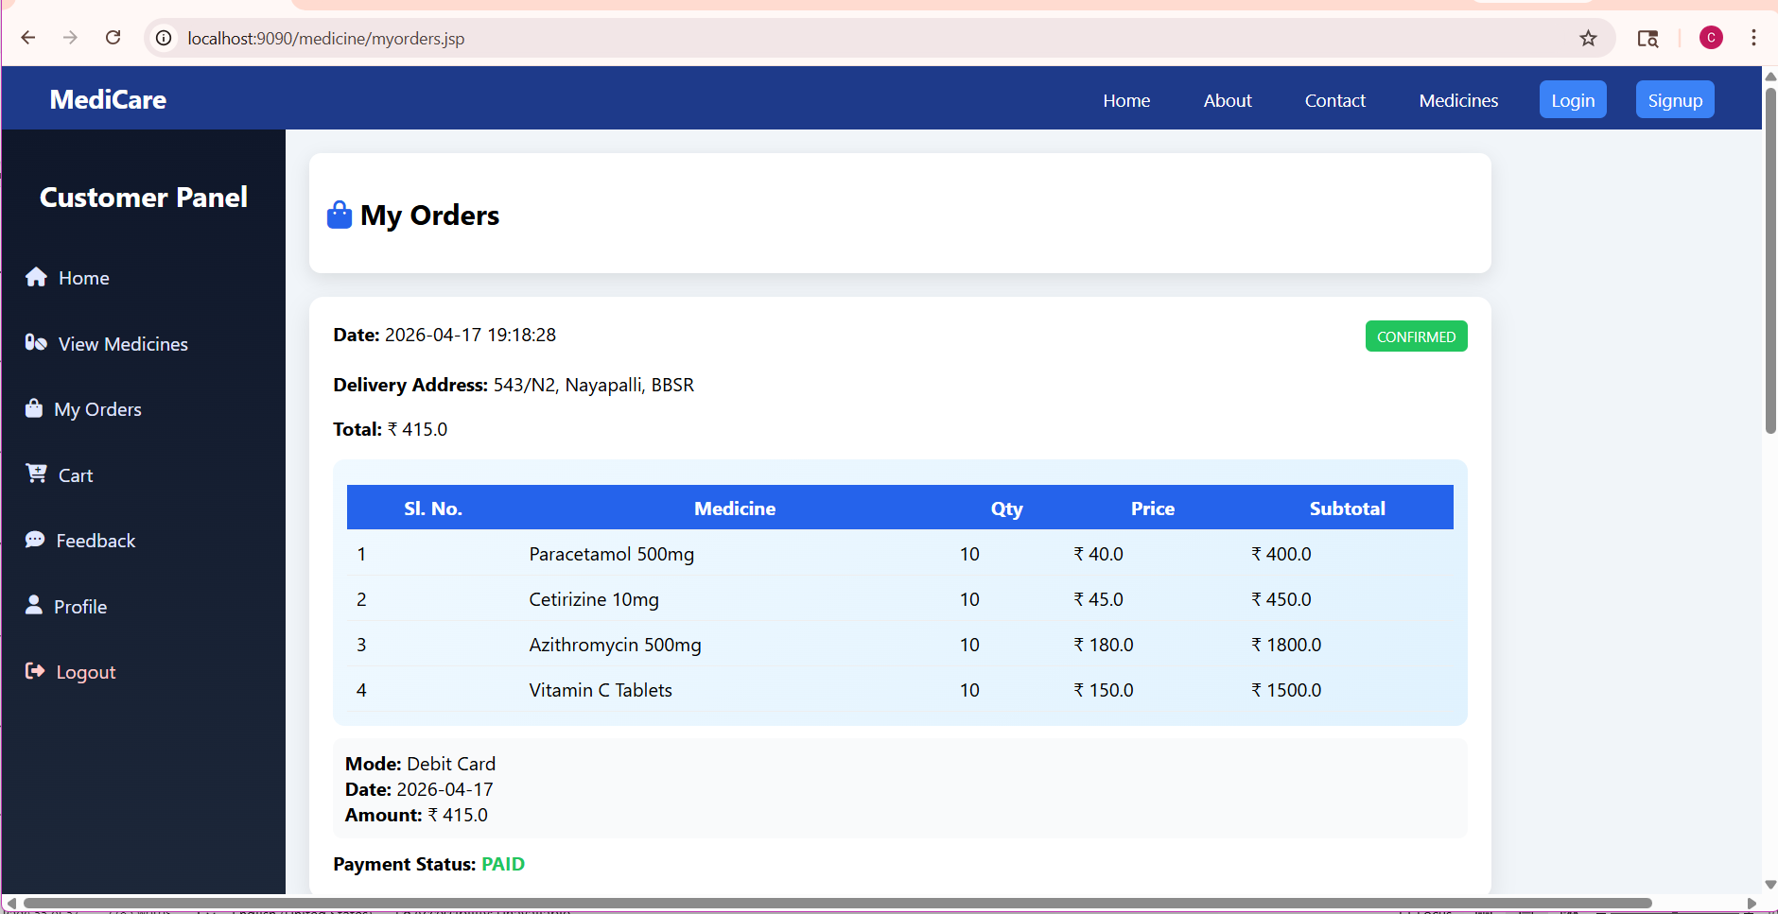

Customer Logout:

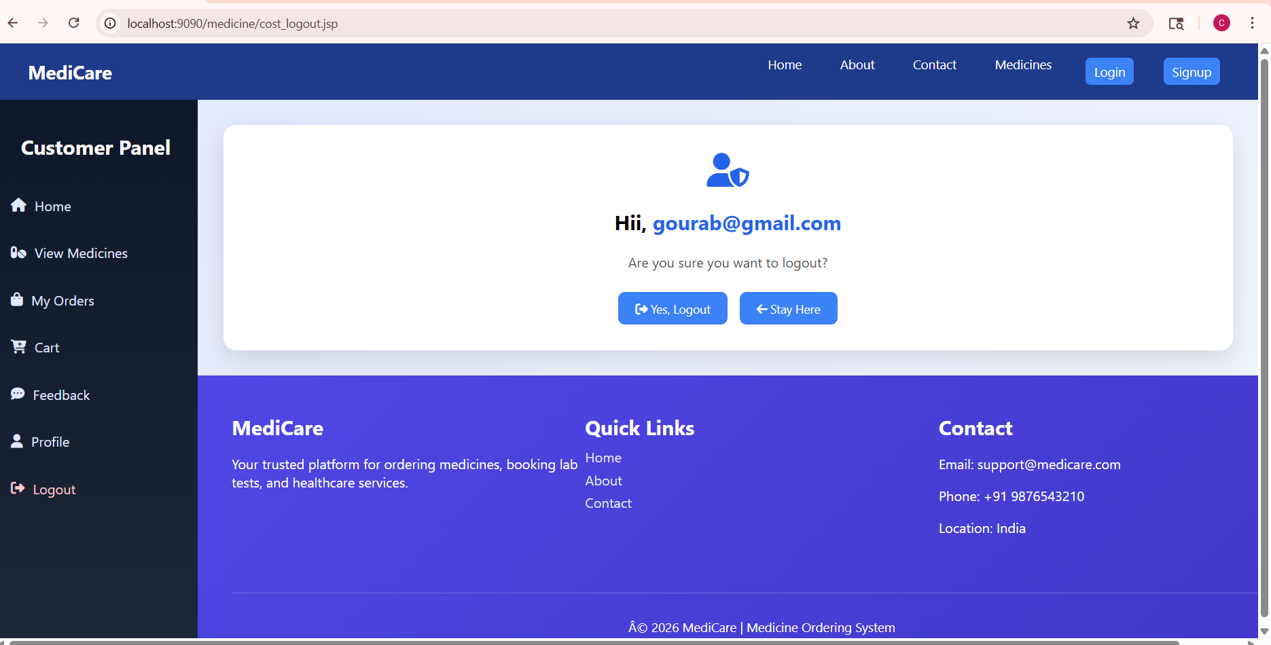

CONCLUSION

The Online Medicine Ordering System has been successfully designed and developed to provide an efficient and user-friendly platform for purchasing medicines online. The system simplifies the traditional method of buying medicines by allowing customers to browse available products, place orders, and make payments through an online interface. It reduces manual effort and improves the accuracy of order processing and record maintenance.

The application includes essential modules such as customer registration, login authentication, medicine management, cart functionality, order processing, payment handling, and feedback management. The administrator can efficiently manage medicines, customers, and orders, while employees can update delivery status, ensuring smooth operation of the system.

The system enhances convenience for customers by enabling them to order medicines anytime and from anywhere. It also helps pharmacy administrators maintain inventory and monitor transactions effectively. The use of a database ensures secure storage and quick retrieval of information.

Overall, the Online Medicine Ordering System improves operational efficiency, minimizes errors, and provides better service to customers. The system can be further enhanced by adding features such as mobile application support, online prescription upload, and automated notifications, making it more robust and scalable for future use.

References

Core Java™ 2 Volume I – Fundamentals 7th Edition - Cay S. Hortsman Pearson Education – Sun Microsystems Gary Cornell

Core Java™ 2 Volume II – Advanced - Cay S. Hortsman Pearson Education – Sun Microsystems Gary Cornell

Head First Servlets & JSP - Eric Freeman O’Reilly – SPD Elisabeth Freeman

The Book of JavaScript 2nd Edition - thau SPD

Effective Java – Programming Language Guide - Joshua Bloch Pearson Education – Sun Microsystems

Java Database Best Practices - George Reese O’Reilly – SPD

JBoss – A Developers Notebook - Norman Richards O’Reilly – SPD Sam Griffith

